Project - 02

In this project, we will learn how to create a static website and deploy it using AWS services. A static website is a site that consists of HTML, CSS, and JavaScript files, and it doesn't require server-side processing or a database.

Documentation For Static Website:-

Step 1: Log in to AWS Management Console:
  - Open AWS Management Console.
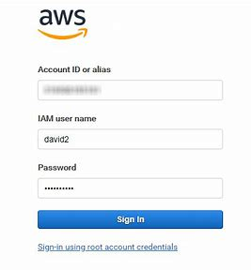

Step 2: Create an S3 Bucket
Navigate to S3 Service:
  - In the search bar, type S3 and select the S3 service.
Create a New Bucket:
  - Click on Create bucket.
2. Provide a unique bucket name (e.g., my-website-bucket).
3. Choose the appropriate AWS region.
4. Leave the default settings and click Create bucket.
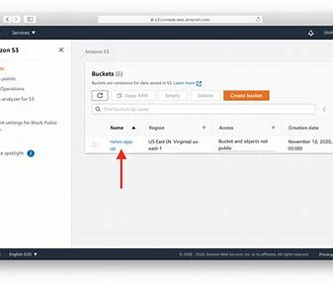

Step 3: Upload Your Website Files to S3
- Select Your Bucket:
- Click on the bucket name you created.
Upload Files:
- Click on Upload.
- Drag and drop your website files into the S3 bucket.
- Click Upload to start the upload process.
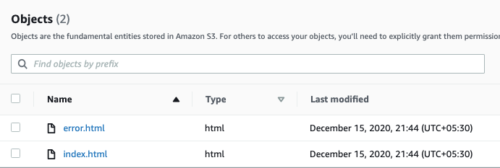

Step 4: Configure the S3 Bucket for Static Website Hosting
- Enable Static Website Hosting:
- Go to the Properties tab of your S3 bucket.
- Scroll down to the Static website hosting section.
- Select Use this bucket to host a website..

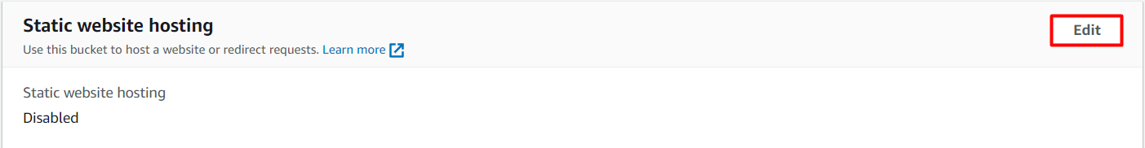
  - Specify the index document (e.g., index.html).
  - Specify the error document (e.g., error.html) if you have one.
  - Click Save
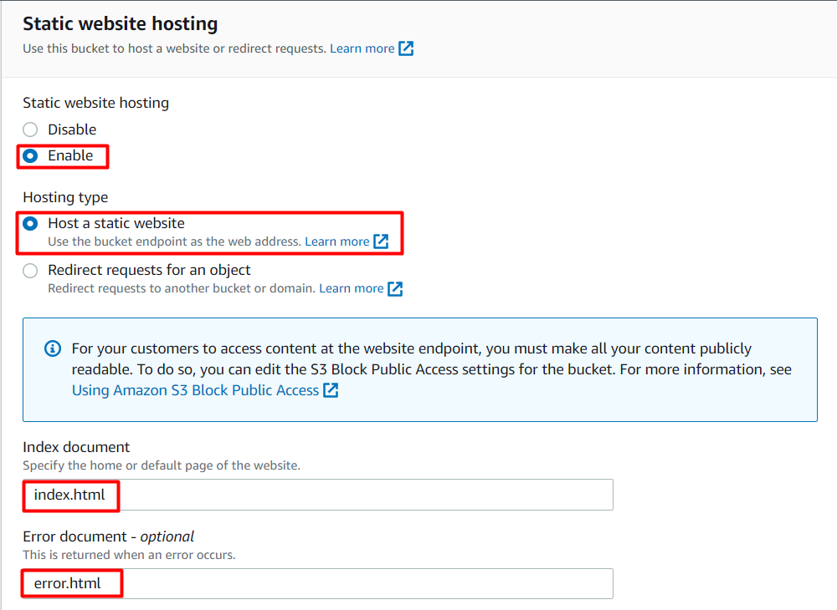

Step 5: Set Bucket Policy to Allow Public Access
- Bucket Permissions:
- Go to the Permissions tab of your S3 bucket.
- Click on Bucket Policy.
2. Add a Bucket Policy:
1. Use the following bucket policy to allow public read access:
json
Copy code

{
"Version": "2012-10-17",
"Statement": [
{
"Effect": "Allow",
"Principal": "*",
"Action": "s3:GetObject",
"Resource": "arn:aws:s3:::my-website-bucket/*"
}
]}

- Replace my-website-bucket with your actual bucket name.
- Click Save.
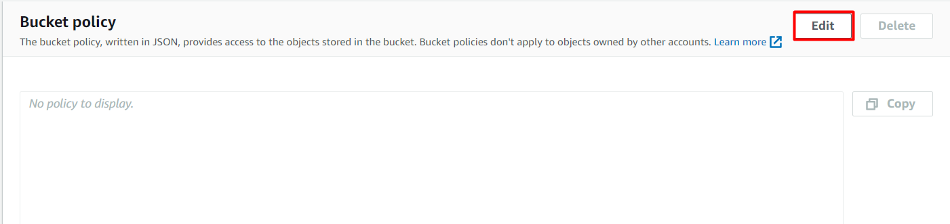

Step 6: Access Your Static Website
- Obtain the Website URL:
- Go to the Properties tab.
- In the Static website hosting section, note the Endpoint URL.

2 Visit Your Website:
- Open a web browser and navigate to the endpoint URL to see your static website live.

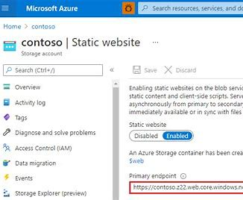

Step 7: Run This URL New Tab in Chrome.
- Finally complete your work and show your created website.

Thank You

Ashish Kumar Shukla
ashishshukla5503@gmail.com

